**Яке місце мають радіо та телебачення в вашому житті?**

***20.10.2023 9А,9Б Хоменко А.Ю.***

**Мета уроку:**

* навчальна: формування лінгвістичної компетентності учнів: використовувати фразові дієслова та ЛО по темі « Радіо і телебачення»
* розвиваюча: формувати та розвивати мовленнєву компетентність учнів
* виховна: формування поведінкових компетенцій, загальну культуру учнів, прищеплення позитивного ставлення до англійської мови.

Procedure

1. **Warm up. Listening.**

- перегляньте презентацію з теми

- <https://youtu.be/Xk7yVmtHzU0?si=0qIuztyjJbHJLSaU>

- які види телепередач ви запам’ятали?

**2. Speaking.**

- розкажіть слова з теми

*Criteria- критерії*

*A dignity - гідність*

*A reliability - надійність*

*To avoid - уникати*

*To judge- засуджувати*

*To substitute- замінити*

*Desperate - відчайдушний*

*Shallow - неглибокий*

*Spiritual – духовний*

1. **Reading.**

**Read the text and do the tasks.**

Computers have had a great impact on society. Today computers are constantly becoming a part of everyday life. Computers are used in eve­rything from the home PC or laptop to appliances such as microwaves and even our cars. Not only have computers had a great impact on our everyday life, but also on education and the workplace. Computers are used in our ap­pliances, mobile phones, entertainment devices (such as DVD players) and others. It is almost impossible to get through one day without having some form of interaction with computers.The Internet has had a huge impact on society. It provides information and services, as well as the ability to communicate people all around the world in variety of ways. These range from bulletin boards and chat rooms to voice conversations and video conferencing.Around the world, the Internet is available to millions of people. Those who don’t have computer or access to the Internet at home will often have access at work or school, or even at the local library. Another added bonus of the Internet is that the majority of the information and services avail­able are free.

The use of computers for educational purposes has been highly benefi­cial for those involved. From a primary school level, children are taught the basics of computer use, including the Internet. At high school, this continues as children become more and more proficient in using the com­puter. It is a tertiary level though, that computers really come into use. News, assignments, tests, lecture notes etc. can be placed on the Internet for students who live in remote areas and cannot travel to and from university or other tertiary institution each day. The idea of remote learning can also be applied to a primary school level.

Computers impact every part of our lives. From the home, to the work­place and in education, computers aid us to do what we want. In general, computers are beneficial to the tasks they are applied to. Although com­puters can cause some problems, such as unemployment and computer vi­ruses, these are far outweighed by the benefits computers provide. Because of this, computersand technology will continue to have an increasing effect on society.

1. **Speaking.**

- опрацюйте True or false: (усно)

1) Society is much influenced by computers at present time.

2) You can find computers everywhere, even in your car.

3) Computers can be operated by microwaves.

4) DVD player is an entertainment device.

5) The Internet is a source of information only.

6) You can’t watch people and hear their voices trough the Internet.

7) You can get access to the Internet at the local library.

8) Not all the information and services available are free.

9) Children are taught the basics of computer use at a primary school level.

10) Computers can be used in education at a distance.

1. **Writing.**

* Запишемо число

*Friday, the 20 of October*

*Classwork*

*Ex. 3 p.71*

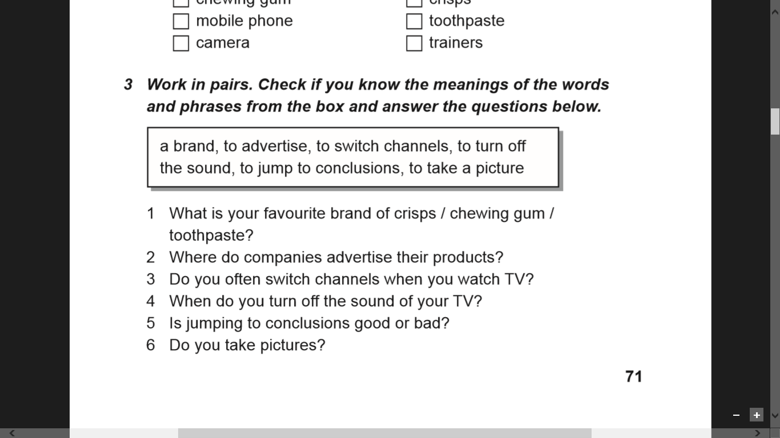

**Homework**:

* дайте відповіді на питання

*1) What is a internet?*

*2) What is the best thing about a internet?*

*3) What is the worst thing about internet?*

*4) What would life be like without your computer or phone?*

*5) Do computers ever make you want to pull your hair out (i.e. become very frustrated)?*

* Письмову роботу чекаю на Human.